Revision History

|  |  |  |  |
| --- | --- | --- | --- |
| Rev | Date | Description | Originator |
| 0.1 | January 19, 2022 | First version – Basic tool | Abed Azem |
| 0.2 | March 25, 2022 | Add function for Direct FFU & check if FW Exist in the Network | Abed Azem |
| 0.3 | May 01,  2022 | Bug fixes and other improvements | Abed Azem |
| 0.4 | August 16, 2022 | User Experience improvement | Abed Azem |
| 0.5 | October 10, 2022 | function efficiency improvement | Abed Azem |
| 0.6 | November 24, 2022 | General Bug fixes and optimizations | Abed Azem |
| 0.7 | November 29, 2022 | 1-Add user input for FFU Loop  2- Config file  3-Automatically path take | Abed Azem |
| 0.8 | November 30, 2022 | Summary File | Abed Azem |

# Work Environment And Preparation

## Operating System

Ubuntu

Tried on 16.04 LTS / 18.04.5 LTS

## Tool

Linux FFU Automation Tool - Based on WDCKIT + BASH Linux Code

**Commands run for first run:**

OS:

1. sudo apt update (After install Ubuntu)
2. sudo apt upgrade (After install Ubuntu)
3. sudo apt install cifs-utils (just for first run)

**Tool:**

Wdckit -> WDCKIT_EULA.txt, first run accept terms (Y) before start the test, run any command

1. Cd /home/qa/Desktop/wdckit-2.13.0.0-x86_64/
2. sudo ./wdckit show all

3- Will ask you if accept terms and Licenses, enter (Y)

## Install steps

1. The Tool folder should located in Main Directory of Wdckit.

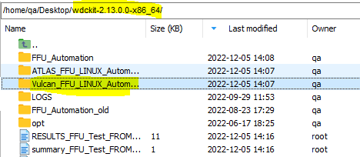

1. Give full permission to **function**, **run2** and **config** files.

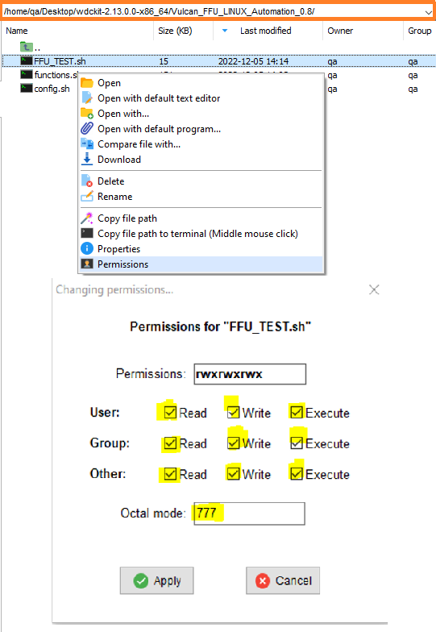

## Test RUN

Before running the test,

Run command:

1. **nvme list** **or ./wdckit show all** - > to get Device Information

/dev/nvme0n1 -> 1

/dev/nvme1n1 -> 2

If need to run the test in both devices - > ALL

**Parameters:**

**Versions FFU & Vendors FFU:**

1. sudo ./run2.sh vulcan SED_Performance_Version AO047VCO AO049VCO 1 vendors customer DE

1-Versions

2-Vendors

3-Direct

1-Ekey

2-customer

1-GO

2-LE

3-DE

4-HP

5-MSFT

1-(1)

2-(2)

3-(All)

FW1

Base FW

File Execution name

Project

Project Version

**Direct FFU:**

1. sudo ./run2.sh vulcan Performance_Version AO050vcp All direct customer DE

1-(1)

2-(2)

3-(All)

FW Version

1-GO

2-LE

3-DE

4-HP

5-MSFT

1-Ekey

2-customer

1-Versions

2-Vendors

3-Direct

Project Version

Project

File Execution name

### Test Steps

1. Identify command
2. Download image
3. FW activate CA=3

|  |  |  |
| --- | --- | --- |
| Step | Test | Test Step Result/Verification |
|  | Identify command | Device Identify |
|  | Download image | 1- Stored. Activation is still required 2- Error: Argument: -f (--firmware) invalid filename |
|  | FW activate CA=3 | 1- Activation was successful. If needed, reboot.  2-Failure (device reported an error) |

## What Test check...

FFU between **Versions**

FFU between **Vendors** (FW1)

ALL

2 Device

1 Device

Device 2

Device 1

ALL

Current to Base

No Key

E-KEY

Customer

Go To Customer **FW1** and FFU to All Vendors

FFU (UP/DOWN)

**CUSTOMER** (GO / DE / LE /HP/MSFT)

Loop

Current TO Base

Back to Base FW

Base TO FW1

FW1 TO Base

Back to Base FW

1 Device

2 Device

ALL

Direct (without Vendors)

Current TO FW

**FFU** (UP/DOWN)

**Configuration File**

In FFU between versions can edit the loop number for FFU times...

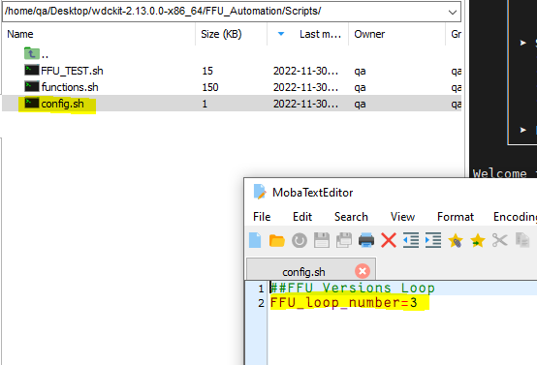

**Summary File**

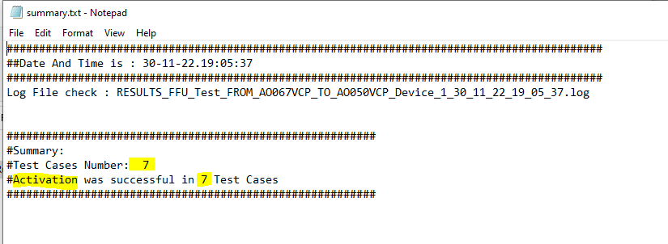

## How to Run the Test:

1. Run the file with bellow parameters : (versions FFU)

* $1 - project - vulcan
* $2 – project Version - Performance_Version
* $3 – fw_base - AO047VCP
* $4 – fw1 - AO049VCP
* $5 – device - (1/2/ ALL)
* $6 – ffu_full - (versions / vendors)
* $7 – KEY - (EKEY/CUSTOMER/NO Key(Empty Parameter))
* $8 – Vendor - (GO/DE/LE/HP/MSFT)

1. Run the file with bellow parameters : (vendors FFU)

* $1 - project - vulcan
* $2 – project Version - Performance_Version
* $3 – fw_base - AO047VCP
* $4 – fw1 - AO049VCP
* $5 – device - (1/2/ ALL)
* $6 – ffu_full - (versions / vendors)
* $7 – KEY - (EKEY/CUSTOMER/NO Key(Empty Parameter))
* $8 – Vendor - (GO/DE/LE/HP/MSFT)

1. Run the file with bellow parameters : (Direct FFU)

* $1 - project - vulcan
* $2 – project Version- Performance_Version
* $3 – fw1 - AO049VCP
* $4 – device - (1/2/ ALL)
* $5 – ffu_full - (direct)
* $6 – KEY - (EKEY/CUSTOMER)
* $7 – Vendor - (GO/DE/LE/HP/MSFT)

#Black – Required

#Red – Not Required

**For example:**

1-**Versions FFU**

* sudo ./run2.sh vulcan SED_Performance_Version AO047VCO AO049VCO 1 versions
* sudo ./run2.sh vulcan Performance_Version AO066VCP AO062VCP 2 versions
* sudo ./run2.sh vulcan SED_Performance_Version AO047VCO AO049VCO All versions
* sudo ./run2.sh vulcan Performance_Version AO067VCP AO050VCP 1 versions customer DE
* sudo ./run2.sh vulcan Performance_Version AO067VCP AO050VCP 1 versions ekey DE

2-**Vendors FFU**

* sudo ./run2.sh vulcan SED_Performance_Version AO047VCO AO049VCO 1 vendors customer DE

3-**Direct FFU**

* sudo ./run2.sh vulcan Debug_Version AO066vcn 1 direct
* sudo ./run2.sh vulcan Performance_Version AO062vcp 2 direct ekey LE
* sudo ./run2.sh vulcan Performance_Version AO050vcp All direct customer DE